**Neutral Fluids Area Information**

**Dasani Water, Powerade and Gels**

**Equipment:**

Tables

Tablecloths

Signage and Bricks (Weight)

Gloves

Jar Grippers/Openers

Dasani Water, Powerade, and for some locations, Energy Gels (caffeinated, then uncaffeinated)

Tape, Razor Blades, Bullhorns, Snacks, Toilet Paper, Hand Sanitizer

**Steps:**

* HAVE FUN!
* Set up tables/tablecloths, spaced according to crew chief’s instruction
* Properly place signage and add Brick
* Order of tables: Gels, Water, Powerade
* Powerade and Water shall placed in a 9 x 6 grid pattern.
* Gels shall be placed right side up in a 12 x 6 grid pattern.
* **DO: Break the seal of the Dasani and Powerade but LEAVE THE TOP ON!**
* **DON’T: Hand the athlete anything!**
* Prepare for each lap, as needed
* Break down area when crew chief gives the “ok”, help other areas until entire hydration station is done
* Return ALL equipment, signage, fluids, etc

**Neutral Area Information:**





**Approximate Set Up of Gels, Water, Powerade**

**GELS: 6 x 12 = 72 per table**

**DASANI WATER: 6 x 9 = 54 per table**

**POWERADE: 6 x 9 = 54 per table**

**CLIF SHOT Energy Gel®** – two caffeinated flavors (Mocha and Citrus) and two un-caffeinated flavors (Boston Cream Pie and Razz) will be available at every location where energy gels are positioned.

*Miles 2,4,8,12,16,20*

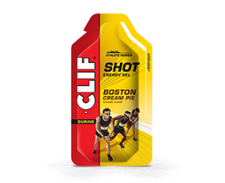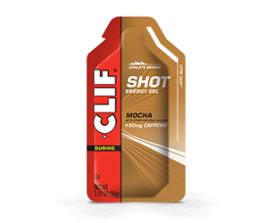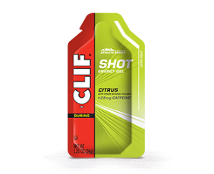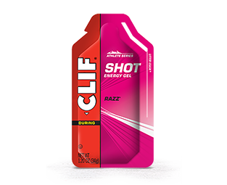

**Powerade**® – 12 oz bottles (Orange flavor) will be available at every general and personal fluids station location.

*Miles 2,4,6,8,10,12,14,16,18,20,22,24*

**Water** – 12 oz bottles of Dasani® bottled water will be available at every general and personal fluids station location.

*Miles 2,4,6,8,10,12,14,16,18,20,22,24*

