November 2019 - Megan McGuigan
Congratulations to our November Volunteer of the Month, Megan McMuigan! Megan has been volunteering with Atlanta Track Club since 2011. After moving to Atlanta, Megan sought out the Club to help her start running. In the time since she has helped other reach their running goals as a Run Lead and Pace Team Member. You'll find her this Thanksgiving Day crossing the finish line leading her pace group at the Invesco QQQ Thanksgiving Day Half Marathon.
Do you remember your first time volunteering with Atlanta Track Club? What brings you back?
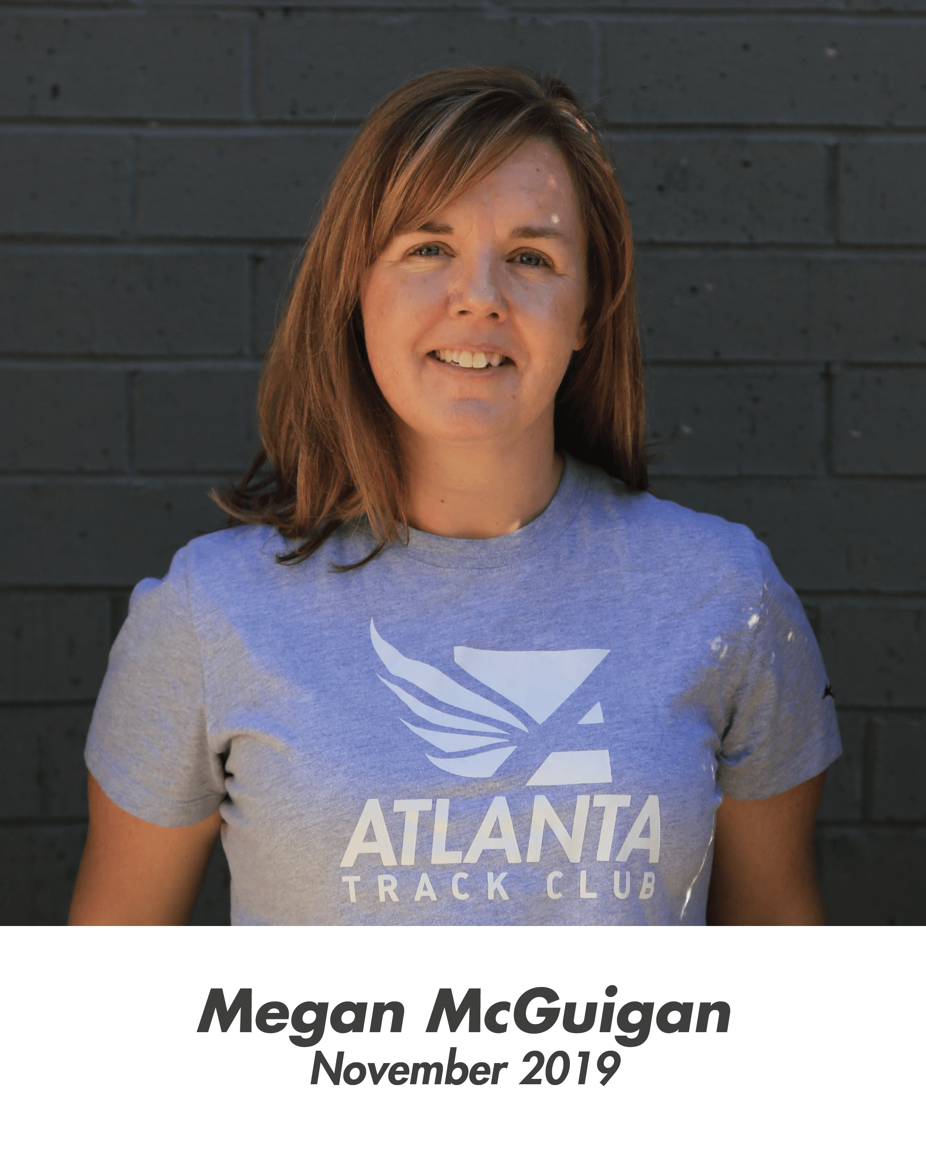
My first event was early number pickup for the AJC Peachtree Road Race. I remember that I was new in town and I didn't know very much about the race at the time, but it seemed like a fun thing to do. It was a bit overwhelming at first, but the energy and excitement from the runners made it fun to be a part of.
Do you have a favorite Atlanta Track Club event?
I have really enjoy all of the events, but this past year for the first time I volunteered at the Anthem Peachtree Junior and I will definitely be back! I was a course monitor and got to cheer on the kids as they ran through Piedmont Park. We then ran the last half mile or so with the final group of runners. Encouraging the kids along the course and seeing them push up the hills was a fun way to spend the morning before running the Peachtree Road Race myself the next day.
What is one of your best memories from volunteering at any race?
I have volunteered as a member of the Pace Team for the Publix Atlanta Half Marathon and Thanksgiving Half Marathon the last two years. The crowds along the courses are great and really motivate us. I enjoy learning about the runners in my pace group. We talk about their training, their goals and anything else we can to distract us as we push through the course. Seeing them cross the finish line is then very rewarding. We're usually still in the finish area and they're already talking about next year's goals!
What is your favorite thing about volunteering with Atlanta Track Club?
My favorite thing about volunteering with Atlanta Track Club is the people who I have met including runners, volunteers and Atlanta Track Club staff. Many of the people I have met through the Club are now among my closest friends. They inspire me every day and I am very fortunate to have met them.
Do you have a favorite volunteer assignment?
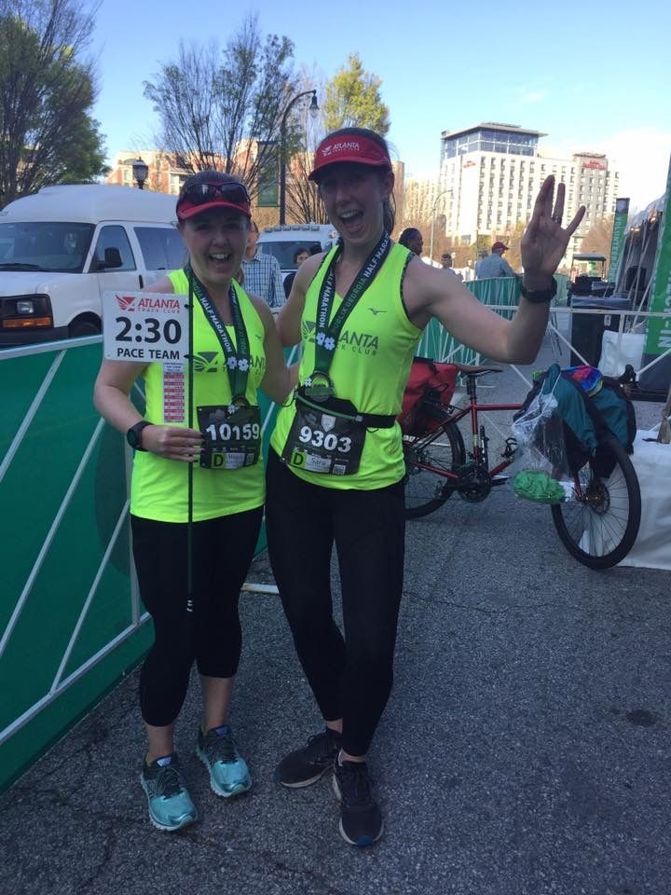Megan (on the left) after pacing the 2018 Publix Atlanta Half Marathon
My favorite volunteer assignment is as a run lead in the various In-Training programs throughout the year. I initially joined Atlanta Track Club for the marathon training program and I learned so much from the coaches and run leads. Becoming a run lead myself has been a fun way to give back. I enjoy the conversations we all have while putting in the miles on Saturday mornings and I learn just as much from the participants as (I hope!) they do from me.
What do you do for a living?
I am a research chemist at the Centers for Disease Control and Prevention
Do you have any words of advice or wisdom for any new Atlanta Track Club volunteers?
My advice to volunteers is to arrive with a smile on your face, a positive attitude and a comfortable pair of shoes!

Anything else you'd like us to know?
I started running shortly after moving to Atlanta a little over 10 years ago. It was my way of learning my way around the city and meeting new people. I am very grateful for this running community who has given me so much and I am excited to have the opportunity to give back!

