As the Texas Renaissance Staff prepares for the 2020 season, TRF Service Manager Sandy Brown has provided the following information for those vendors, performers, artisans, and staff who receive passes and those who utilize participant camping for the season.

How to get to the Pass Office
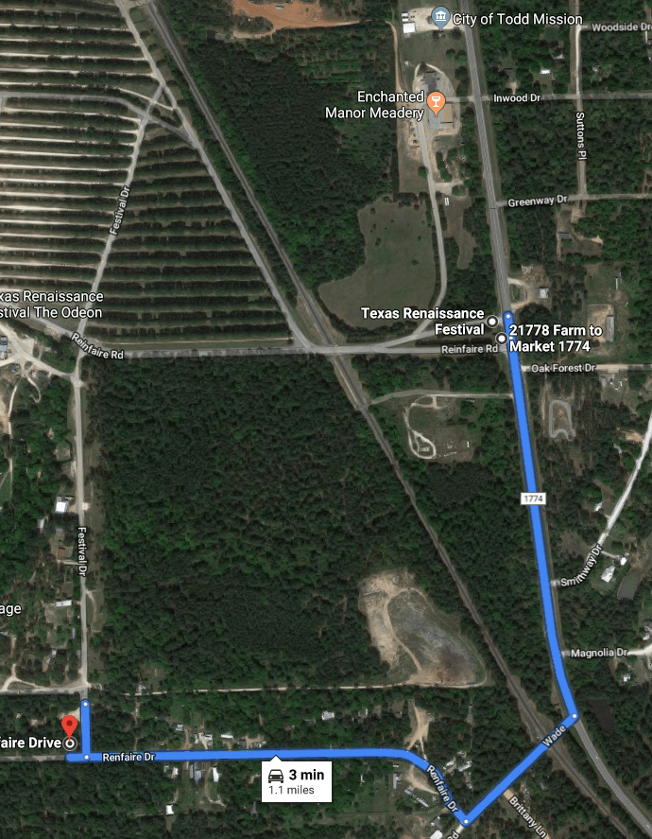

From 1774 turn on Wade Road, Turn Right on Renfaire Dr., Turn right on Festival Dr., Pass Office will be on your left before the festival gate.

TRF 2020 ID Badge
To reduce onsite Pass Office traffic, you will be able to apply for your ID badge starting August 1 online. The form is still being developed but will be ready by the August 1 date. You can also send any questions directly related to ID badges to badges@texrenfest.com.
Passes are $10 cash only. Lost or replacement passes are $75 cash only.
You must have your pass form signed by an authorized TRF representative or Booth Owner prior to arriving at the Pass Office.

Participant Camping
You will be able to make Participant Camping reservations at the Pass Office starting August 8. Credit cards can only be accepted for Participant Camping.

Pass Office Rules
The number of people allowed in the Pass Office at one time will be limited. A protective glass is being added at the counter. At this time, it has not been determined if face masks inside the office will be required.

Pass Office Hours
August | Thur & Fri  12 pm - 7 pm | Saturdays  8 am - 2 pm
September  (Closed Labor Day) | Mon - Fri  12 pm - 7pm | Sat & Sun  8 am - 2 pm | Job Faire  9/5 - 9/6  8 am - 5 pm | Rehearsal  09/26  8 am - 5 pm
October | Thur - Fri  12 pm - 7pm | Sat & Sun  7 am - 3 pm
November | Fridays  12 pm - 7 pm | Sat & Sun  7 am - 3 pm | School Days  11/4 - 11/5  7 am - 12 pm

